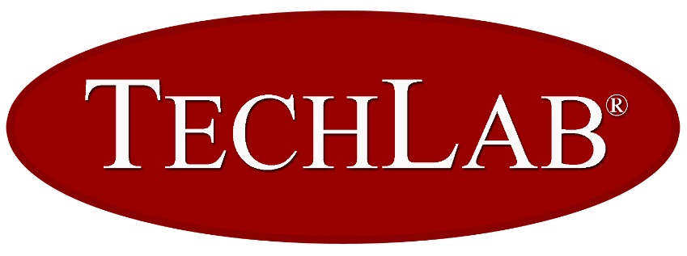
Radford Location
20 Corporate Drive Radford, VA 24141

Blacksburg Location
2001 Kraft Drive Blacksburg, VA 24060

Job Title: Technical Product Support Associate
(Effective 08/30/2021)

Company Overview
TECHLAB®, Inc. was founded in 1989 by scientists from the Virginia Tech Anaerobe Lab, one of the only three institutions in the world dedicated to the study of anaerobic organisms. In the late 1970′s and early 1980′s, research headed by Dr. Tracy Wilkins began on Clostridium difficile and its toxins.

Today the company develops, manufactures and distributes intestinal diagnostics worldwide retaining an emphasis on science and collaborations with universities. Products are focused in the areas of intestinal inflammation, antibiotic associated diarrhea, foodborne illness, and parasitology. Research continues on markers of intestinal inflammation, the toxins of Clostridium difficile, and amebiasis. TECHLAB®, Inc. has ISO 13485 certification along with FDA registration. For more information, visit www.techlab.com.

Job Summary
The job of Technical Product Support Associate is to provide technical support and technical service documentation for TECHLAB products and Services. The Technical Product Support Associate can expect to prepare and maintain files as appropriate, as well as coordinate, prepare, and assist review of technical documentation. The Technical Support Associate will report to the Director of Regulatory & Compliance and Technical Services.

Work Activities
- Provide technical support for TECHLAB diagnostic products
- Technical service calls / documentation
- Field technical service calls and emails regarding product performance and provide troubleshooting
- Coordinate investigative testing including testing of retentions and customer returns
- Coordinate discrepant sample (fecal) analysis for customers
- Perform surveys regarding overall customer satisfaction
- Assist in laboratory as necessary to evaluate current, new products, and competitive products
- Assist in the review of technical support literature including but not limited to FAQs and technical training materials
- May assist in the review of marketing literature as requested
- Coordinate gold standard testing to validate TECHLAB kits
- Monitor and compile information regarding customer issues in weekly spreadsheet
- Monitor customer complaints
- Propose changes as Document Circulation Requests (DCRs)
- Assessment of the need for Medical Device Reporting (MDR) and Medical Device Vigilance (MDV)
- Other duties as necessary

Tools and Equipment Used
- Microsoft Office Suite
- Other software as necessary

Job Context
TechLab® maintains a climate-controlled environment for the job of Technical Product Support Associate when on-site. A typical workday is an 8 hour shift, Monday through Friday between the hours of 8:00 a.m. EST and 8:00 p.m. EST, overtime is occasionally necessary with or without advance notice.

Minimum Qualifications
- BA/BS or higher
- 3-5 years of Clinical laboratory experience, preferably MT/CLS or equivalent experience
- Ability to communicate effectively with diverse groups including physicians, lab managers and technicians

